VIET NAM GENERAL CONFEDERATION OF LABOUR

**TON DUC THANG UNIVERSITY**

**FALCUTY OF ELECTRICAL – ELECTRONIC**



**LE DINH BAO HUY**

**DESIGN IOT-BASED SOLAR TRACKING AND POWER MONITORING OF PV SYSTEMS FOR HOSPITAL SMART SYSTEMS**

**UNDERGRADUATE THESIS OF ELECTRICAL ENGINEERING**

**HO CHI MINH CITY, YEAR 2023**

VIET NAM GENERAL CONFEDERATION OF LABOUR

**TON DUC THANG UNIVERSITY**

**FALCUTY OF ELECTRICAL – ELECTRONIC**



**LE DINH BAO HUY – 418H0120**

**DESIGN IOT-BASED SOLAR TRACKING AND POWER MONITORING OF PV SYSTEMS FOR HOSPITAL SMART SYSTEMS**

**UNDERGRADUATE THESIS OF ELECTRICAL ENGINEERING**

Advised by

**Dr. Fayaz Hussain**

**HO CHI MINH CITY, YEAR 2023**

**ACKNOWLEDGEMENTS**

During the 5 years of studying and training at Ton Duc Thang University, this graduation project is an important milestone marking the completion of a student's mission in the university lecture hall. Within the scope of my project, I have tried to present the research and design of clean energy models.

I sincerely thank the lectures of the Faculty of Electrical Engineering – Ton Duc Thang University for enthusiastically teaching and imparting their valuable knowledge to me. In particular, I would like to thank the enthusiastic guidance of Mr. Fayaz Hussain lecturer of the Department of Electrical and Electronics Engineering at Ton Duc Thang University, who dedicatedly guided and instructed me during the thesis process. Besides, I would not have been able to complete this project without the support of Dr. Huynh Van Van from Ton Duc Thang University. Their dedicated guidance, advice, and comments were very helpful for my project.

I would also like to sincerely thank my family and friends who have always been by my side to encourage me during the process of making this project as well as during the past study.

*Ho Chi Minh City, 16th July, 2023*

*Author*

This thesis was carried out at Ton Duc Thang University.

Adviser: Dr Fayaz Hussain.........................................................

......................................................................................

*(Title, full name and signature)*

This thesis is defended at the Undergraduate Thesis Examination Committee was hold at Ton Duc Thang University on 16 /07/2023

Confirmation of the Chairman of the Undergraduate Thesis Examination Committee and the Dean of the faculty after receiving the modified thesis (if any).

**CHAIRMAN DEAN OF FACULTY**

…………………………. ………………………………

**DECLARATION OF AUTHORSHIP**

I hereby declare that this thesis was carried out by myself under the guidance and supervision of Dr. Fayaz Hussain lecturer and that the work and the results contained in it are original and have not been submitted anywhere for any previous purposes. The data and figures presented in this thesis are for analysis, comments, and evaluations from various resources by my own work and have been duly acknowledged in the reference part.

In addition, other comments, reviews and data used by other authors, and organizations have been acknowledged, and explicitly cited.

**I will take full responsibility for any fraud detected in my thesis.** Ton Duc Thang University is unrelated to any copyright infringement caused on my work (if any).

*Ho Chi Minh City, 16th July 2023.*

*Author*

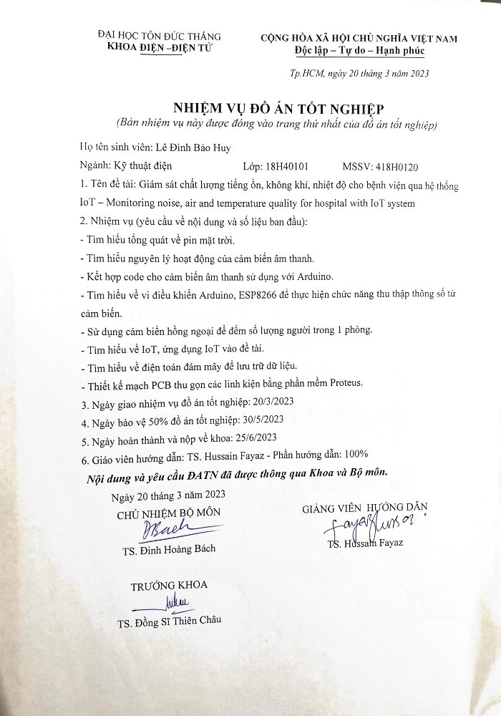

|  |  |
| --- | --- |
| TON DUC THANG UNIVERSITY  **FACULTY OF ELECTRICAL AND ELECTRONIC ENGINEERING**  ------------------- | SOCIALIST REPUBLIC OF VIETNAM  Independence – Freedom – Happiness  ---------------------- |

**GROUP PROJECT SCHEDULE**

Student: Lê Đình Bảo Huy

Class: 18H40101 Student ID: 418H0120…………

Project: Design IoT-based solar tracking and power monitoring of PV systems for hospital smart systems.

|  |  |  |  |
| --- | --- | --- | --- |
| **Week/Day** | **Work** | | **Advisor signed** |
| **Done** | **Continue** |
| Week 1 (20/03/2023 - 26/03/2023) | Meet with the advisor to know the requirements of the project, proceed to select the topic of the project. | The advisor show the overview of the topic. |  |
| Week 2 (27/03/2023 - 02/04/2023) | Found the topic for the project. The advisor recommended project’s system. | Study about Solar Basis, solar panels, tracking solar and IOT. |  |
| Week 3  (03/04/2023– 09/04/2023) | Looking for hardware, learn how it works. | Collect enough components, understand the nature of components. |  |
| Week 4  (10/04/2023 - 16/04/2023) | Learn Arduino programming language to apply for every sensors in the system. | Understanding the sensor pins out diagram |  |
| Week 5  (17/04/2023 - 23/04/2023) | Learn ESP8266 programming language to apply for every sensors in the system. | Connected components with Arduino and ESP8266 . microcontroller. |  |
| Week 6  (24/04/2023 - 30/04/2023) | Learned about basics of code for run equipments | Understanding the sensor pins out diagram. |  |
| Mid-term check | Evaluation of completed volume ……%  be allowed to continue/discontinue | | |
| Week 7  (01/05/2023 – 07/05/2023) | Try to connect pins of sensor to Arduino | Started code in arduino |  |
| Week 8  (08/05/2023 – 14/05/2023) | Research on photoresistance, how to design tracking solar system | Get an overview of how it works |  |
| Week 9  (15/05/2023 – 21/05/2023) | Buy the necessary components: photoresistor, servoMG996, iron frame, .. | Completed tracking solar system. |  |
| Week 10  (22/05/2023 – 28/05/2023) | Do send data to blynk | Finishing model and test again all project |  |
| 50% progress assessment | | | |
| Week 12  (05/06/2023 – 11/06/2023) | Meet french students, talk about machine learning | Collect data from air conditioning, apply code and analysis |  |
| Week 13  (12/06/2023 – 18/06/2023) | Write the graduation thesis | Completed graduation thesis |  |
| Week 14  (19/06/2023 – 25/06/2023) | Make a powerpoint to present | Completed the powerpoint |  |
| Week 15  (03/07/2023 – 09/07/2023) | Completed 100% Graduation Project |  |  |
| Submit | Complete …..% Undergraduate thesis  be protected/unprotected Undergraduate thesis. | | |

**DESIGN IOT-BASED SOLAR TRACKING AND POWER MONITORING OF PV SYSTEMS FOR HOSPITAL**

**ABSTRACT**

The need for electricity is growing daily as technology advances. As a result, the usage of renewable energy sources, particularly solar energy, is more popular than ever because it is sustainable and kind to the environment.

I am in charge of designing and testing the charge controller for the project of designing solar tracking and power monitoring of PV systems. For the battery to last as long as possible and to maintain the necessary voltage for the system to function, the charging method must be dependable enough to charge the battery..

**CONTENTS**

LIST OF FIGURES 3

LIST OF TABLES 5

CHAPTER 1. INTRODUCTION 1

1.1 Introduction 1

1.2 The objectives of the topic 1

1.3 Overview about solar energy in the world 2

CHAPTER 2. LITERATURE REVIEW 5

2.1 Overview about solar energy 5

2.1.1 Definition 5

2.1.2 Solar energy in Vietnam 7

2.2 Solar energy system configuration. 9

2.2.1 Off-grid solar energy system. 9

2.2.2 On-grid solar energy system. 9

2.3 Solar energy applications 10

2.3.1 Solar power plant 10

2.3.2 Solar electricity 11

2.3.3 Solar vehicle 12

2.4 Solar panel 13

2.4.1 Structure 13

2.4.2 Working principle 15

CHAPTER 3. METHODOLOGY 17

3.1 System overview 17

3.2 IoT System Overview 17

3.3 Components 18

3.3.1 Solar panel 18

3.3.2 Solar charge controller 19

3.3.3 Lead acid battery 20

3.3.4 Microcontroller Arduino R3 21

3.3.5 Module Wifi ESP8266 23

3.3.6 Step-down module LM2596 25

3.3.7 Current-Voltage Sensor INA219 25

3.3.8 Light sensor (LDR) 26

3.3.9 Servo MG996 28

3.3.10 Voltage divider 29

3.4 Caculate the power consumption 29

3.5 Printed circuit board 30

3.6 Control programming and operation 32

3.6.1 Arduino IDE 32

3.6.2 The Blynk platform 34

CHAPTER 4. RESULTS AND DISCUSSION 35

4.1 Describe the operating procedure 35

4.2 Solar tracking operation 36

4.3 Analysis 37

4.3.1 Testing without tracking solar 37

4.3.2 Testing with tracking solar 38

4.3.3 Comparison 39

CHAPTER 5. CONCLUSIONS 43

5.1 Final Hardware 43

5.2 Advantage of model 45

5.3 Disadvantage of model 45

5.4 Future Works 45

REFERENCES 47

# LIST OF FIGURES

Figure 1‑1: World’s electricity production by source IEA 2019 3

Figure 1‑2: Percent of world electricity generation by source BP statistical review of world energy 2019 4

Figure 2‑1: Radiation from sun to earth 6

Figure 2‑2: Photovoltaic power potential source by WBG. 7

Figure 2‑3: Solar radiation map of Vietnam by source The World Bank in 2017 8

Figure 2‑4: Off-grid solar energy system 9

Figure 2‑5: On-grid solar energy system 10

Figure 2‑6: Trung Nam - Thuan Nam solar power plant in VietNam 11

Figure 2‑7: Solar energy for home 12

Figure 2‑8: Solar energy car 13

Figure 2‑9: Structure of solar panel 15

Figure 2‑10: Working principle of solar panel 16

Figure 3‑1: Solar panel 18

Figure 3‑2: Apollo Battery 21

Figure 3‑3: Arduino Uno R3 22

Figure 3‑4: ESP8266 24

Figure 3‑5: Pin definition of ESP8266 24

Figure 3‑6: DC-DC buck LM2596 25

Figure 3‑7: Current-Voltage Sensor 26

Figure 3‑8: Creation and to section of LDR 27

Figure 3‑9: Servo MG996R 28

Figure 3‑10: Voltage divider with Arduino 29

Figure 3‑11: Principle diagram on Proteus software 31

Figure 3‑12: 3D of PCB on Sprint-Layout Software 32

Figure 3‑13: Tracking solar code interface on software 33

Figure 3‑14: Blynk interface 34

Figure 4‑1: Operation diagram 35

Figure 4‑2: Testing without non-tracking solar 38

Figure 4‑3: Voltage difference between 2 cases 40

Figure 4‑4: Current difference between 2 cases 40

Figure 4‑5: power obtained in 10 hours between 2 cases 41

Figure 5‑1: The solar tracking of PV systems with hospital smart systems 43

Figure 5‑2: Outcome on Blynk App 44

# LIST OF TABLES

Table 3‑1: Parameter of solar panel 18

Table 3‑2: PWM details 19

Table 3‑3: Parameter of 12V 7.5Ah lead acid battery 21

Table 3‑4: Parameters of Uno R3 22

Table 3‑5: INA219 details 26

Table 3‑6: Servo motor specifications 28

Table 3‑7: Total power consumption 29

Table 4‑1: Measured parameters without the tracking solar system 38

Table 4‑2: Measured parameters with the tracking solar system 39

# INTRODUCTION

## Introduction

Renewable energy, in which solar energy has been and is being researched and used by the whole world. The demand for solar energy supply for systems that need small and medium-sized energy sources but need high efficiency such as applications in traffic lights, public lighting systems, fishing boat systems at sea, in security devices etc. very necessary. However, solar power systems are facing a problem that if the panels are placed in a fixed position, they only get the maximum capacity during a few peak hours of the day, so the efficiency is not high. In this project, we apply Internet Of Things (IoT) technology to the design and construction of the solar cell navigation system, which can monitor the system on the Smartphone App via the Internet and navigate the solar panels in the direction of the solar panel. movement of the sun during the day to achieve high energy conversion efficiency.

## The objectives of the topic

The application of IoT to the solar panel system will help users to monitor the operation of the device remotely in real time and help reduce operating costs. With the help of this control measure, solar energy can be harnessed with maximum efficiency. At the same time, the IoT application system to monitor and navigate the system contributes to creating a safe system, bringing high economic efficiency. The system includes sensors: current sensor, voltage sensor, light intensity sensor. The information collected from the sensor will be sent to the Arduino Microcontroller for processing and sent to the user via the Internet by the ESP8266 module. Users will use App Blynk to monitor and monitor the operating status of the system. The light-emitting cam will automatically recognize and adjust the direction so that the surface of the solar cell is always perpendicular to the direction of the sun to get the most energy, suitable for the time of day. The parameters will be sent to the phone via the Internet. The system has the following functions:

* Navigate the solar panel towards receiving the most light through the light sensor.
* Analyze of solar energy and consumption of the load.
* To supply and analyze solar energy for hospital smart systems
* IOT application for PWM charge controller to monitor status of solar energy system

## Overview about solar energy in the world

Nowadays, the demand for electricity is increasing, we must manufacture power in a variety of methods. However, some forms of electricity production have a negative influence on the environment, prompting us to look for ways to produce electricity using clean, renewable energy sources. The environmental consequences of consuming fossil fuels can have a significant impact on people's quality of life. The combustion of fossil fuels combines carbon in the fuel with oxygen in the air to generate CO2, which is then released into the atmosphere. CO2 levels in the oceans are also rising. In addition to pollution created by fossil fuels, it has resulted in some environmental disasters.

The total amount of electricity consumed worldwide was 12,696 TWh in 2000, 16,738 TWh in 2010, 23,921 TWh in 2019.

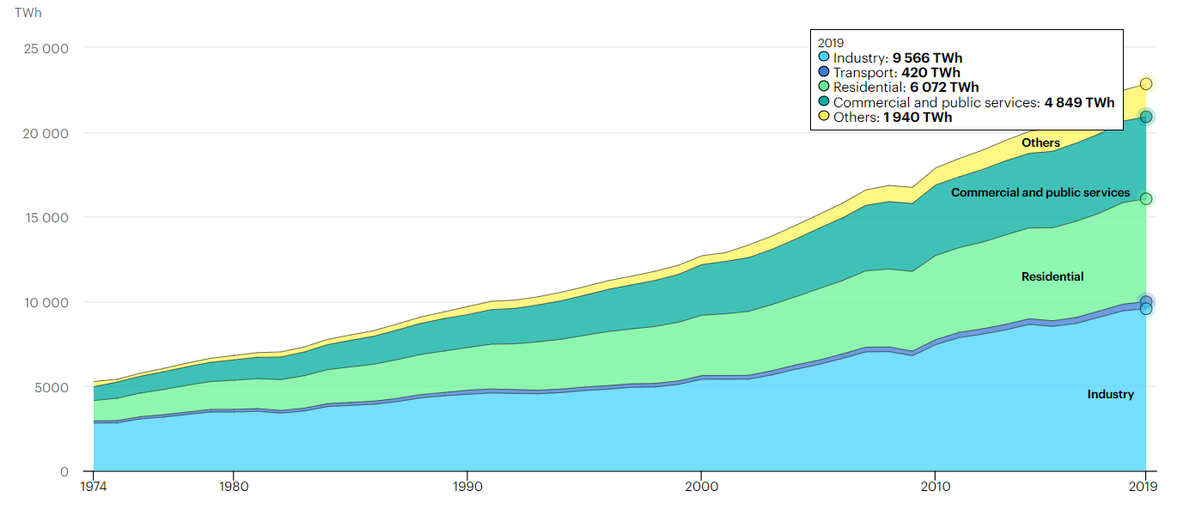

Figure ‑: World’s electricity production by source IEA 2019

As we can see, the need for useful energy is increasing. However, as environmental concerns mount, the development of thermal power and hydropower schemes becomes increasingly problematic. People have been searching for oil, gas, and coal for thousands of years, so every time one of those finite resources is burnt to generate energy, that finite resource is moved a little closer to exhaustion.

By the end of 2018, the share of world energy consumption for electricity generation by source was coal at 38%, natural gas at 23%, hydro at 16%, oil at 3%, nuclear at 10%, renewable energy at 9% and other energy is nearly 1%.

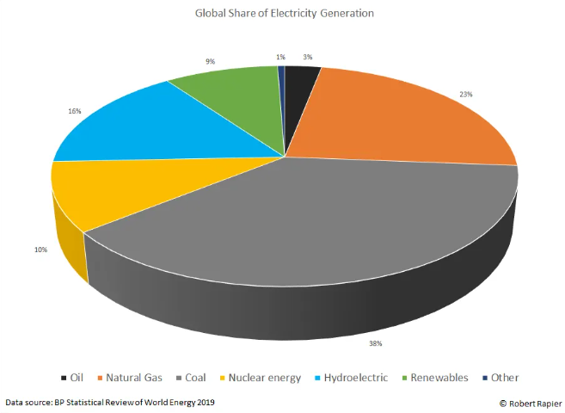

Figure ‑: Percent of world electricity generation by source BP statistical review of world energy 2019

By the end of 2019, the share of world energy consumption for electricity generation by source was coal at 38%, natural gas at 23%, hydro at 16%, oil at 3%, nuclear at 10%, renewable energy at 9% and other energy is nearly 1%.

As we can see, the need for useful energy is increasing. However, as environmental concerns mount, the development of thermal power and hydropower schemes becomes increasingly problematic. People have been searching for oil, gas, and coal for thousands of years, so every time one of those finite resources is burnt to generate energy, that finite resource is moved a little closer to exhaustion. That is why renewable energy is seen as a valuable resource in many countries throughout the world. Wind, solar, and hydropower are examples of renewable energy sources that are utilized to generate electricity that does not deplete the resource. Solar energy is a terrific idea for a renewable energy solution. Solar energy is a clean, affordable, renewable energy source that is available all around the world. The earth's surface has the ability to generate solar energy.

# LITERATURE REVIEW

## Overview about solar energy

### Definition

Solar energy, radiation from the Sun capable of producing heat, causing chemical reactions, or generating electricity. The total amount of solar energy incident on Earth is vastly in excess of the world’s current and anticipated energy requirements. If suitably harnessed, this highly diffused source has the potential to satisfy all future energy needs. In the 21st century solar energy is expected to become increasingly attractive as a renewable energy source because of its inexhaustible supply and its nonpolluting character, in stark contrast to the finite fossil fuels coal, petroleum, and natural gas.

Solar powerafter absorbing light from the sun that is converted into thermal or electrical energy. Solar energy is the cleanest and most abundant renewable energy source available, and the U.S. has some of the richest solar resources in the world. Solar technologies can harness this energy for a variety of uses, including generating electricity, providing light or a comfortable interior environment, and heating water for domestic, commercial, or industrial use.

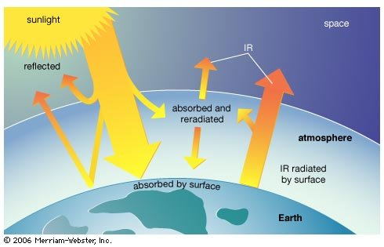

Figure ‑: Radiation from sun to earth

The Sun is an extremely powerful energy source, and sunlight is by far the largest source of energy received by Earth, but its intensity at Earth’s surface is actually quite low. This is essentially because of the enormous radial spreading of radiation from the distant Sun. A relatively minor additional loss is due to Earth’s atmosphere and clouds, which absorb or scatter as much as 54 percent of the incoming sunlight. The sunlight that reaches the ground consists of nearly 50 percent visible light, 45 percent infrared radiation, and smaller amounts of ultraviolet and other forms of electromagnetic radiation.

There are three main ways to harness solar energy: photovoltaics, solar heating & cooling, and concentrating solar power. Photovoltaics generate electricity directly from sunlight via an electronic process and can be used to power anything from small electronics such as calculators and road signs up to homes and large commercial businesses. Solar heating & cooling (SHC) and concentrating solar power (CSP) applications both use the heat generated by the sun to provide space or water heating in the case of SHC systems, or to run traditional electricity-generating turbines in the case of CSP power plants.

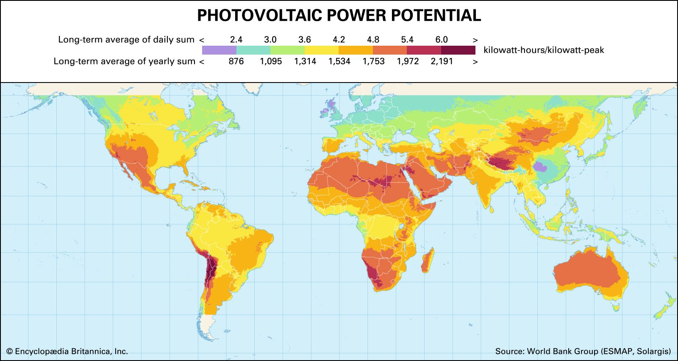

Figure ‑: Photovoltaic power potential source by WBG.

Solar energy is the world leader in power generation capacity and is regarded as a cost-effective source of electricity generation. Solar power is a sustainable and clean energy source that is gaining popularity around the world. Globally, 176 gigatonnes (GW) of renewable energy sources were installed in 2019.

### Solar energy in Vietnam

Vietnam is considered as a country with great potential for solar energy. The map of Vietnam's solar radiation is prepared by three leading Spanish research institutes, CIEMAT, CENER, and IDEA, based on data from 171 hydrometeorological stations in Vietnam that measure the number of hours of sunshine in 30 years. , satellite image database for 5 years and data of 12 automatic hydrometeorological measurement stations for 2 years.

According to the radiation map developed by the World Bank (WB), the potential of solar energy in Vietnam is theoretically huge. Solar radiation intensity ranges from 897 to 2108 kWh/m2/year, equivalent to 2.46 and 5.77 kWh/m2/day (MOIT & AECID, 2015). The highest radiation intensity is concentrated in the Central Highlands and Southern provinces such as Dak Lak, Gia Lai, Nha Trang, Ninh Thuan, Binh Thuan, Tay Ninh and Binh Phuoc.

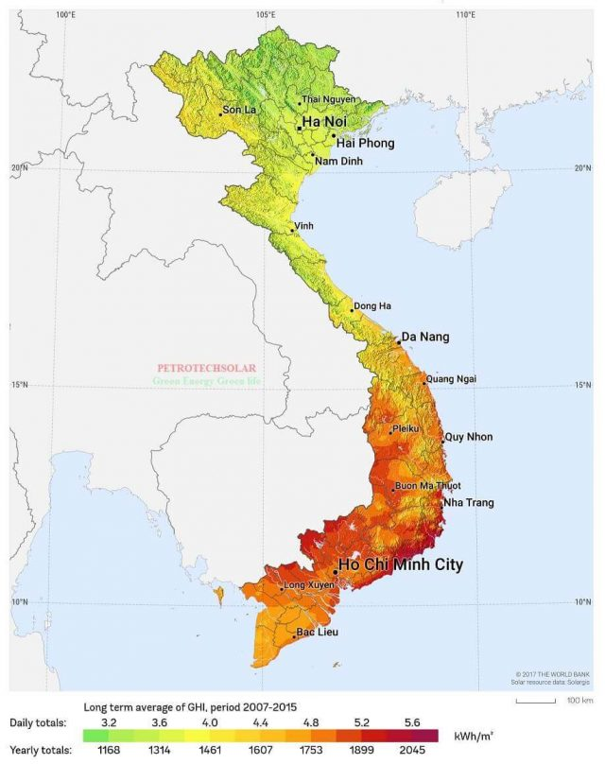

Figure ‑: Solar radiation map of Vietnam by source The World Bank in 2017

## Solar energy system configuration.

### Off-grid solar energy system.

The most popular sort of solar energy system is an independent solar energy system. The main objective is to deliver electricity in areas where access to energy is difficult or unavailable. The operation of an independent solar energy system is as follows: a solar panel generates DC voltage, which charges and stores electricity in a battery. The inverter transforms DC electricity to AC voltage, whereas the converter transfers DC voltage to DC voltage, depending on the load.

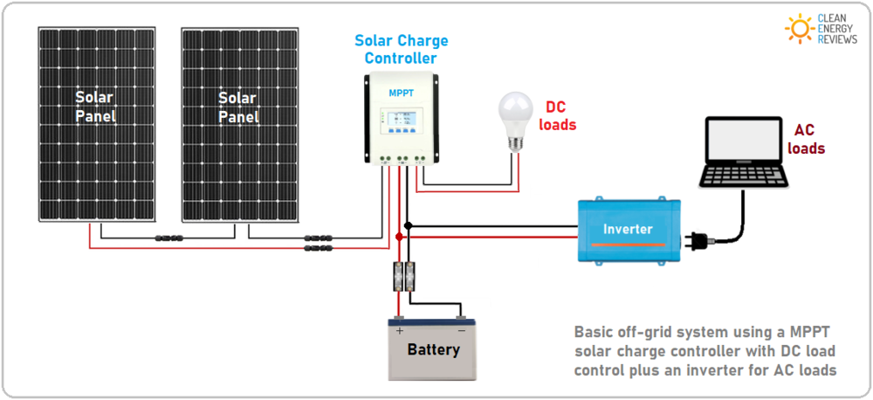

Figure ‑: Off-grid solar energy system

### On-grid solar energy system.

On-grid solar power system is a solar power generation system where it is connected to the utility grid. The electricity produced by the system is routed to the grid from where it is used to run the various appliances. The installation of the same is also fuss-free and easy to maintain.

The amount of electricity utilized during the day in an on-grid solar energy system is mostly supplied by the solar energy system. The grid generally supplies electricity in the evening. Solar energy systems perform best during the day. This technology is also quite efficient in terms of power demands for daily operations. The on-grid solar energy system works as follows: when the solar panel absorbs solar radiation, a DC voltage is generated, and the inverter converts the DC voltage to AC in the same phase and frequency as the grid power and the additional power supply.

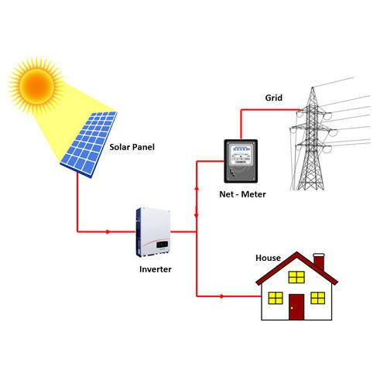

Figure ‑: On-grid solar energy system

## Solar energy applications

### Solar power plant

A solar power plant, also known as a solar power plant or photovoltaic power plant, is a plant that uses solar energy to generate electricity.

Currently, solar power is classified as a clean renewable energy source that should be encouraged to develop. Because this energy source not only contributes to the supply of electricity for production and living for people, but also helps to combat the ongoing global climate change phenomenon.

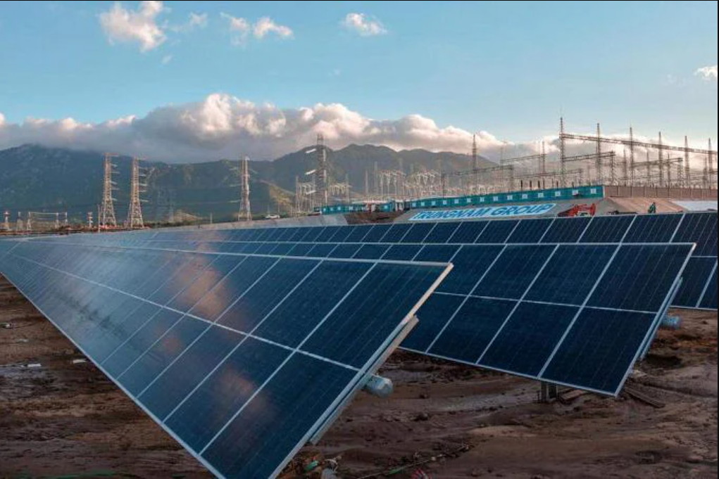

Figure ‑: Trung Nam - Thuan Nam solar power plant in VietNam

### Solar electricity

This is one of the most popular solar energy applications in recent years. PV systems are put on the roofs of homes that are linked to the electric grid. The solar system generates electricity to power homes in order to reduce electric costs or to transfer any excess electricity output back to the grid.

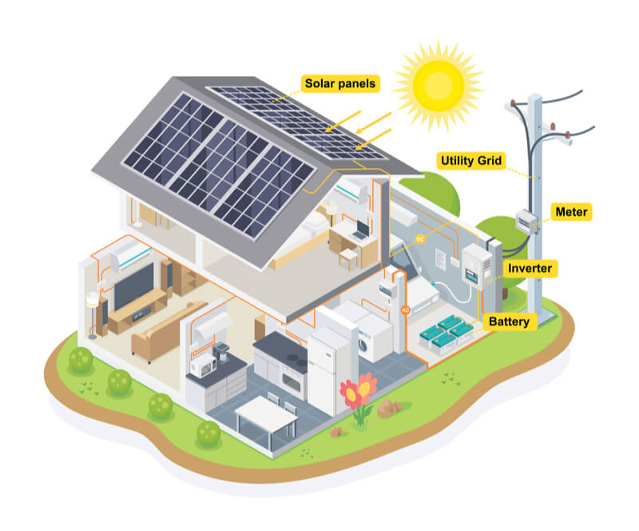

Figure ‑: Solar energy for home

### Solar vehicle

Nowdays, some automakers have adopted solar powered applications, equipped with solar panels mounted on the hood. The first solar-powered supercar was the Lightyear one. The car can accelerate to 100km in 10s. When fully charged, the car will travel a distance of 725 km. Each hour of charging in the sun will help the car go more 12km.

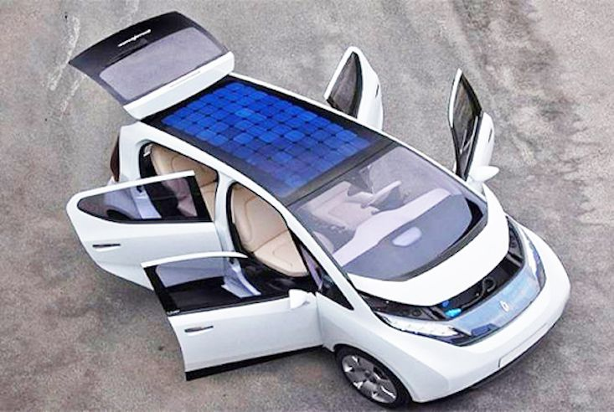

Figure ‑: Solar energy car

## Solar panel

### Structure

In solar, we have seven main parts:

- Photovoltaic cells: It convert sunlight directly into DC electrical energy. Solar panel efficiency is determined by the cell type and characteristics of the silicon used, with the two main types being monocrystalline silicon and polycrystalline silicon. The base of the PV cell is a very thin wafer, usually 0.1mm thick and made of either positive P-type silicon or negative N-type silicon. Various cell sizes and configurations provide different levels of efficiency and performance including halving or split cell, multibus bus (MBB) cell.

- Tempered glass: The front glass panel protects the PV cells from weather and impact from hail or airborne debris. The glass is typically high tempered with a thickness of 3.0 to 4.0mm and is designed to resist mechanical loads and extreme temperature changes.

- Extruded aluminum frame: The aluminum frame plays an important role by both protecting the edge of the laminate that covers the cells and providing a solid structure to hold the panel in place. The extruded aluminum sections are designed to be extremely light, rigid and able to withstand and withstand high loads from high winds and external forces.

- Packing – EVA film layers: EVA stands for 'ethylene vinyl acetate' which is a specially designed layer of highly transparent polymer (resin) used to enclose cells and hold them in place during manufacturing. EVA material must be extremely durable and resistant to extreme temperatures and humidity, it plays an important part in long-term performance by preventing the ingress of moisture and dirt.

- Polymer rear panel: The back panel is the last layer of conventional panels, acting as a moisture barrier and a final outer layer to provide both mechanical protection and electrical insulation. Back plate materials made from different polymers or resins including PP, PET and PVF provide varying degrees of protection, thermal stability and long-term UV protection. They are usually white but also clear or black depending on the manufacturer and module.

- Junction box – diodes and connectors: The junction box is a small weatherproof enclosure located at the back of the panel. It is necessary to securely attach the cables necessary to connect the panels to each other. The junction box is important because it is the central point where all the cells are connected and must be protected from moisture and dirt.

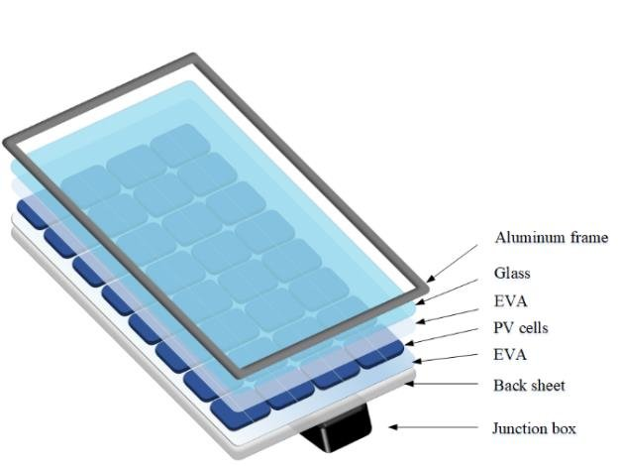

Figure ‑: Structure of solar panel

### Working principle

Solar cells generate electricity via the photovoltaic effect. Standard solar cells are made up of P-type silicon, N-type silicon, and one P-N junction. P-type and N-type silicon will be electrically neutral at first. When sunlight strikes the cell, electrons travel to the negative electrode and holes to the positive electrode. The negative electrode is connected by a conducting wire. Solar cells generate direct current (DC) electricity and supply it to loads.

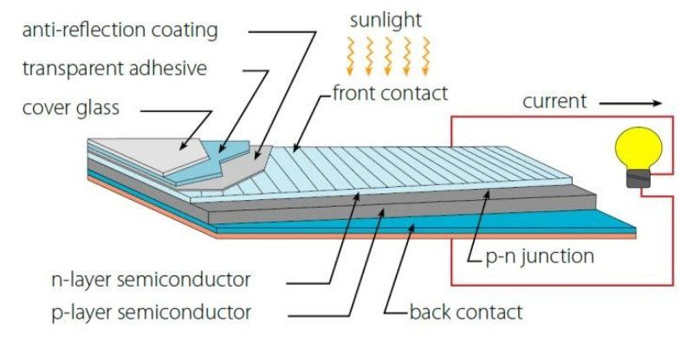

Figure ‑: Working principle of solar panel

# METHODOLOGY

## System overview

The solar charge controller receives voltage when the solar panel is illuminated; it then automatically adjusts the output voltage to the necessary output voltage to charge the lead acid battery. The battery will be in charge of power storage, and the voltage lowering circuit will supply power to the Arduino and active sensors. The ESP8266 module will receive the signal from the sensors and transmit it, allowing us to monitor the parameters online using PCs, smartphones, and other devices as long as they have a network.

## IoT System Overview

The Internet of Things (IoT) is a network of interconnected computers, mechanical and digital machines, or humans, and it has the capacity to send data over a network without requiring human-computer contact.

The application of IoT in this project is to be able to transmit parameters and data from the solar cell to anywhere, as long as your device has internet.

Advantages of IoT:

* Access information from anywhere, anytime on any device.
* Improved communication between connected electronic devices.
* Transferring data over the Internet saves time and money.
* Automating tasks to help improve service quality of businesses.

## Components

### Solar panel

We require roughly 5W of load electricity for this project. Because the reduction in efficiency of solar panels is approximately 20%-25%, we require a 20W solar panel to ensure continuous power delivery to the load.

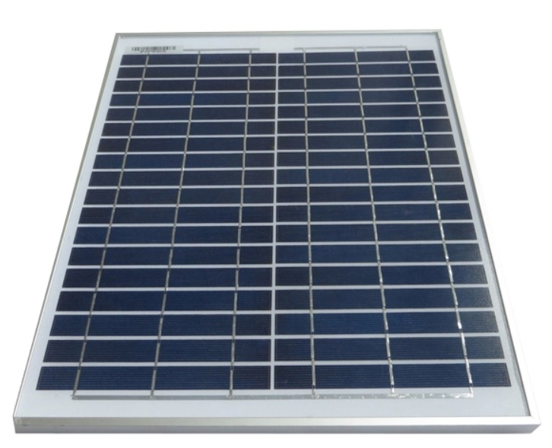

Figure ‑: Solar panel

Table ‑: Parameter of solar panel

|  |  |
| --- | --- |
| Peak power | 20(W) |
| Production tolerance | 0+3(%) |
| Maximum power current | 1.4(A) |
| Maximum power voltage | 17.5(V) |
| Open circuit voltage | 21.24(V) |
| Weight | 1.94Kg |

### Solar charge controller

Solar charge controller is an intermediate device between the solar panel and the battery, it is used to optimally control the battery charging process from the solar battery, helping the charging process to always reach the highest efficiency as well as preserve the battery life. battery protection with PWM smart charging process.

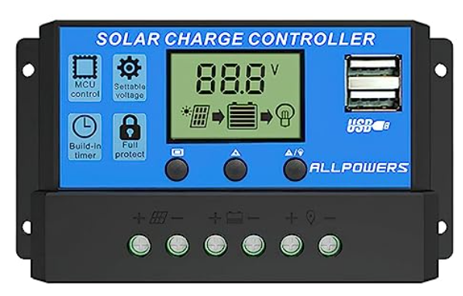

Figure 3. Solar charge controller

Table ‑: PWM details

|  |  |
| --- | --- |
| Solar charge controller PWM | |
| Rated voltage | 12/24V |
| Rated current | 10A |
| Max PV voltage | 50V |
| Max PV input power | 130W for 12V |

### Lead acid battery

A battery is a secondary source of electricity, which works on the conversion of chemical energy into electricity. The battery creates and maintains a potential difference between the two ends of an electrical circuit. It has the effect of storing and supplying electricity to electrical appliances. So battery is the common name of rechargeable power source for reuse.

The battery is a crucial item in this system because it stores energy to deliver electricity to the system when it is dark or the PV output is low. As a result, we must select a good battery that will provide continuous power:

We can calculate the suitable battery by use formula:

$$Ah=\frac{T×W}{n_{b}×DOB×V_{baterry}}$$

In which:

* Ah: required Ampere-hours (Ah) from batteries.
* $E_{load}=$ $ΣP_{load}×t$: the load of date (Wh/hours).
* D: Number of days to using battery (day).
* ηb : Efficiency of battery; 80%-85%.
* DOD: depth of discharge = 0.6 - 0.65

The system requires continuous power supply throughout the day. However, the average sunrise time in Ho Chi Minh City is 12.7 hours. As a result, we require an 11.3-hour battery power supply.

$$Ah=\frac{3.365×11.3}{0.85×0.65×12}=5.735$$

* So we choose 12V-7.5Ah battery to ensure the system is working smoothly.

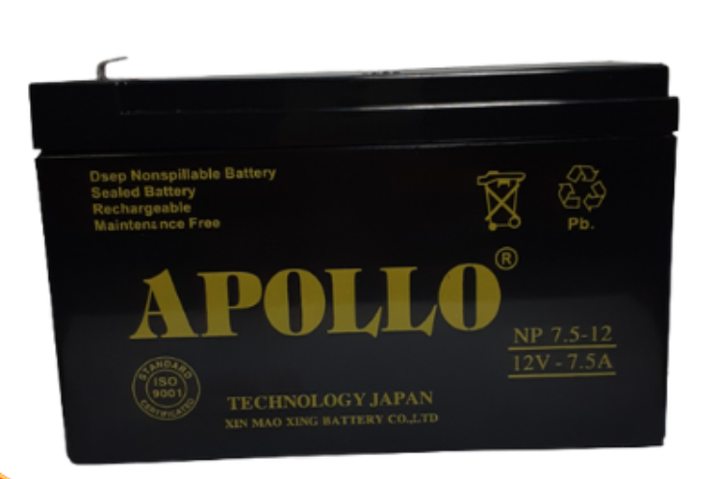

Figure ‑: Apollo Battery

Table ‑: Parameter of 12V 7.5Ah lead acid battery

|  |  |
| --- | --- |
| Brand | Apollo |
| Voltage | 12V |
| Capacity | 7.5Ah |
| Max Current | 7.5A |
| Max Charge Voltage | 12.68V |
| Weight | 2.5kg |

When the battery is employed as a backup power source for load, it is considered to be in standby mode. The battery is kept at float charge to keep it fully charged so that it can take up the load right away if the main power supply fails.

### Microcontroller Arduino R3

Arduino UNO is a microcontroller board based on the **ATmega328P**. It has 14 digital input/output pins (of which 6 can be used as PWM outputs), 6 analog inputs, a 16 MHz ceramic resonator, a USB connection, a power jack, an ICSP header and a reset button. It contains everything needed to support the microcontroller; simply connect it to a computer with a USB cable or power it with a AC-to-DC adapter or battery to get started. You can tinker with your UNO without worrying too much about doing something wrong, worst case scenario you can replace the chip for a few dollars and start over again.

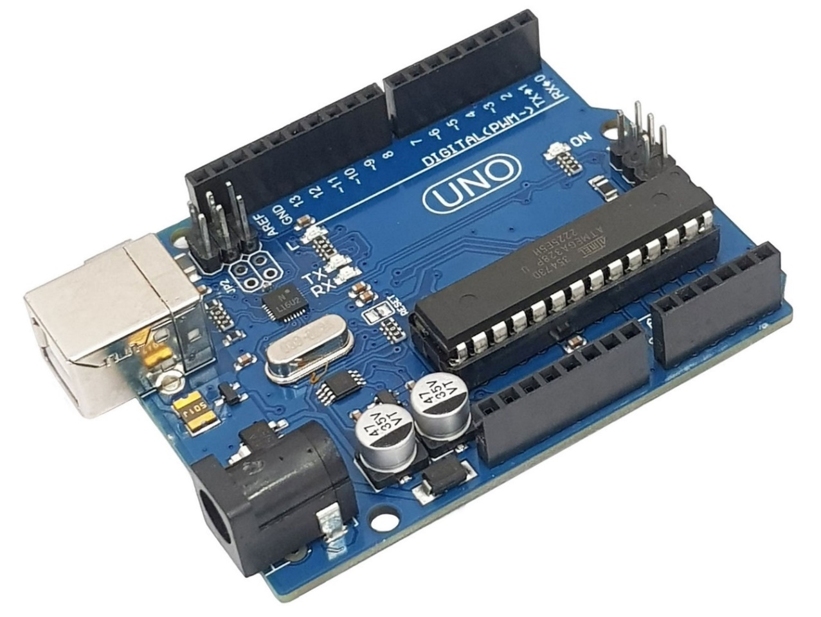

Figure ‑: Arduino Uno R3

Table ‑: Parameters of Uno R3

|  |  |
| --- | --- |
| **Microcontroller** | **ATMEGA328P** |
| **Operating Voltage** | 5V |
| **InputVoltage (recommended)** | 7-12V |
| **Input Voltage (limit)** | 6-24V |
| **Digital I/O Pins** | 14 (of which 6 provide PWM output) |
| **Analog Input Pins** | 6 |
| **DC Current per I/O Pin** | 20 mA |
| **DC Current for 3.3V Pin** | 50 mA |
| **Flash Memory** | 32 KB |
| **SRAM** | 2 KB |
| **EEPROM** | 1 KB |
| **Clock Speed** | 16 MHz |
| **LED_BUILTIN** | 13 |

### Module Wifi ESP8266

The ESP8266 is a system on chip (SoC), manufactured by the Chinese company Espressif. It includes a 32-bit Tensilica L106 microcontroller (MCU) and a Wi-Fi transceiver. It has 11 GPIO (General Purpose Input/Output) pins and one analog input, which means you can program it just like you would with an Arduino or other microcontroller. The ESP8266 chip itself has 17 GPIO pins, but 6 of these pins (6-11) are used to interface with the onboard flash memory chip. Also it has Wi-Fi connectivity, so you can use it to connect to Wi-Fi networks, connect to the Internet, host web servers with real websites, let your smartphone connect hooked to it, ... The possibilities are endless! No wonder this chip has become the most popular IoT device available.

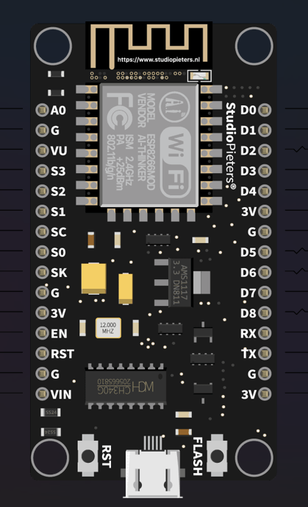

Figure ‑: ESP8266

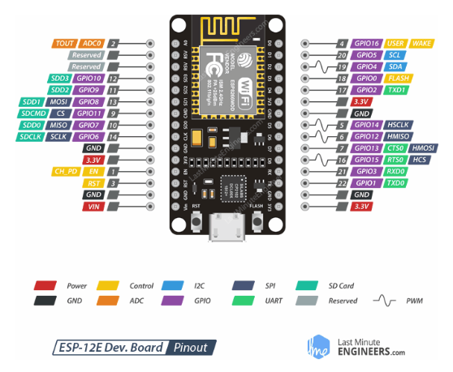

Figure ‑: Pin definition of ESP8266

### Step-down module LM2596

With an output current of up to 3A and a frequency of 180Khz, the LM2596 DC-DC buck voltage reducer circuit employs pulse pressure reduction to lower DC voltage. It also features an integrated output voltage meter and an aluminum heatsink for the main IC. This module's advantages are its tiny size, simplicity of usage, high output current, and suitability for small models.

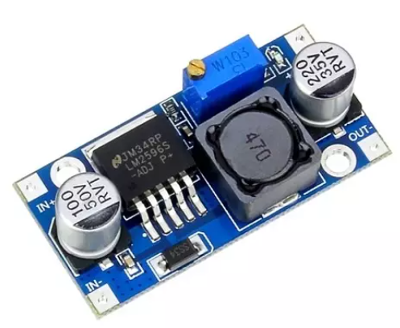

Figure ‑: DC-DC buck LM2596

### Current-Voltage Sensor INA219

INA219 is used to measure DC voltage and current of devices with high accuracy combined with 12-bit resolution, ±1% error. Besides, this sensor circuit uses I2C interface to help us easily connect to the microcontroller for programming, suitable for current and voltage measurement applications.

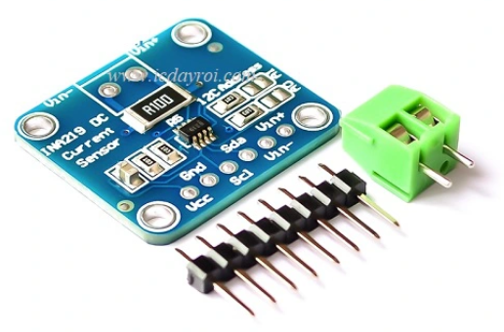

Figure ‑: Current-Voltage Sensor

Table ‑: INA219 details

|  |  |
| --- | --- |
| Working voltage | 3.0~5.5VDC |
| Voltage measuring range | 0~26VDC |
| Current measuring range | 0~3.2A |
| Power measuring range | 0~83.2W |
| Connect methot | TWI/I2C |

### Light sensor (LDR)

The photoresistor sensor is a light-dependent resistor (LDR), sometimes known as a photosensitive resistor. The most common and widely used form of light sensor, based on analysis, provides a consistent, clear signal and high accuracy. This sensor is mostly utilized at night for billboards and street lighting...

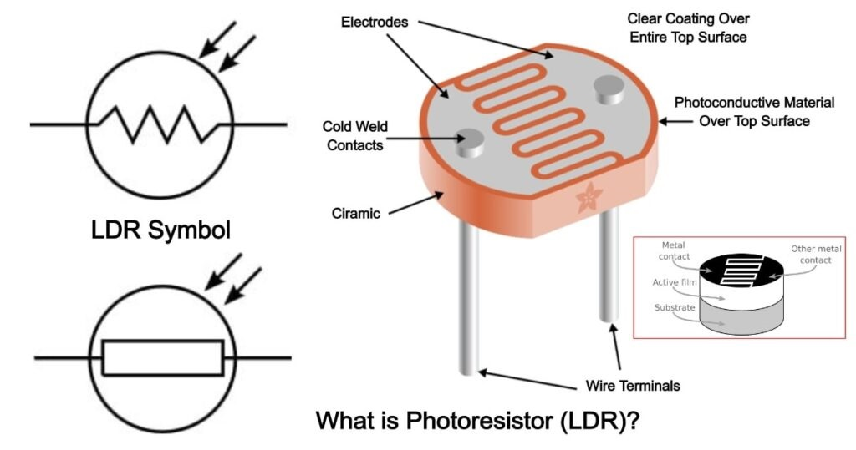

Figure ‑: Creation and to section of LDR

Some advantages of LDR sensor points such as:.

* Used in alarm clocks
* Used in housebreaker alarm circuits
* Used in light intensity meters
* Used as part of a SCADA system to implement purposes such as counting the number of packages on a moving conveyor belt etc
* Used in tracking solar models

### Servo MG996

The**MG996R** is a**metal gear servo motor** with a maximum stall torque of 11 kg/cm. Like other RC servos the motor rotates from 0 to 180 degree based on the duty cycle of the PWM wave supplied to its signal pin.

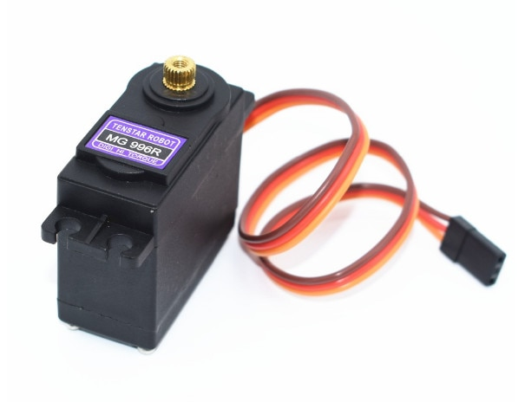

Figure ‑: Servo MG996R

Table ‑: Servo motor specifications

|  |  |
| --- | --- |
| Voltage | 4.8 → 7.2 VDC |
| Rotation | 90 → 180 degree |
| Size | 40 x 19 x 43mm |
| Working speed | 0.17s/60º (4.8V); 0.13s/60º (6V) |
| Momen | 3kg.cm |
| Temperature working | 0°C ~ 55°C |

### Voltage divider

The voltage divider is used to measure the photoresistor's output voltage. The voltage sensor employs the voltage divider principle to measure a big voltage source in the microcontroller board, however the microcontroller board can only sense voltages from 0 to 5V. This allows the arduino analog pins to be used to monitor the voltage. After monitoring the voltage, the algorithm will calculate a number that corresponds to the voltage output by the photoresistor.

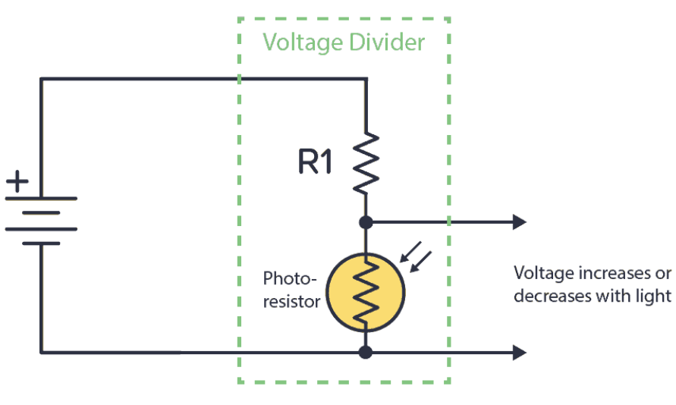

Figure ‑: Voltage divider with Arduino

## Caculate the power consumption

Table ‑: Total power consumption

|  |  |  |  |  |  |
| --- | --- | --- | --- | --- | --- |
| **Number** | **Device** | **Amount** | **Current (mA)** | **Voltage**  **(V)** | **Power**  **consumption (W)** |
| 1 | Arduino R3 | 2 | 30 | 5 | 0,3 |
| 2 | ESP8266 | 2 | 70 | 5 | 0,7 |
| 3 | LCD20*4 | 1 | 150 | 5 | 0.75 |
| 4 | Sound Sensor | 1 | 40 | 5 | 0,2 |
| 5 | Air Sensor | 1 | 50 | 5 | 0,25 |
| 6 | Wind sensor | 1 | 20 | 5 | 0,1 |
| 7 | Humidity  Sensor | 1 | 3 | 5 | 0,015 |
| 8 | Dust Sensor | 1 | 10 | 5 | 0,05 |
| 9 | Pir Sensor | 2 | 25 | 5 | 0,25 |
| 10 | Servo MG996 | 1 | 150 | 5 | 0,75 |
| Total power consumption | | | | | 3.365 |

## Printed circuit board

In a PCB, all the components are connected wirelessly and are wired internally, thus reducing the complexity of the overall circuit design. PCBs are used for power supply and connections between components. PCB can be customized to any specifications as required. In this project I choose through-hole PCB, in this type of PCB, I have to make holes by drilling on the PCB. In these holes, the leads of the components are attached and soldered to the pads located on the opposite side of the PCB. This technology is useful because it gives more mechanical support to electronic components and is a reliable technology for mounting components.

I use Proteus and Sprint-layout software which I used to study in my 3rd year of university to designing and making PCB circuit for this project.

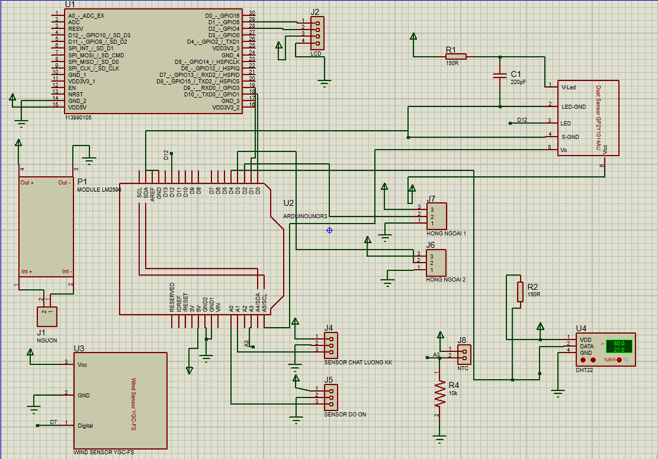

Figure ‑: Principle diagram on Proteus software

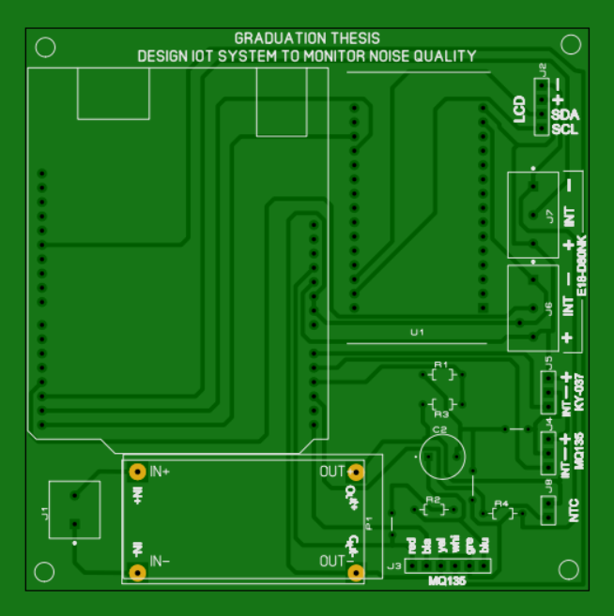

Figure ‑: 3D of PCB on Sprint-Layout Software

## Control programming and operation

### Arduino IDE

Arduino IDE is a design chip platform or source code platform with the purpose of enabling communication and interaction amongst electrical applications that have been designed by humans. In order to simplify and ease the complexity of electrical projects, Arduino is also used to replace the code loading tools for programmers..

* Can detect and gather data from sensors to determine the state of a board, a system, etc..
* Arduino may also be used to control gaming displays, joysticks, and other devices.
* Arduino is useful for IoT programming, programming robotics, and automated programming for vehicles such as automobiles and airplanes..
* • In addition to being able to connect to many devices, Arduino can also do so using a far smaller control chip,...

The Arduino Integrated Development Environment (IDE) is a platform for developing applications (available for Windows, MacOS, and Linux) that uses C and C++ as its programming languages. It is used to create and upload programs to a development board from a different manufacturer, as well as an Arduino comparable board when using a third-party core.

#### Code application

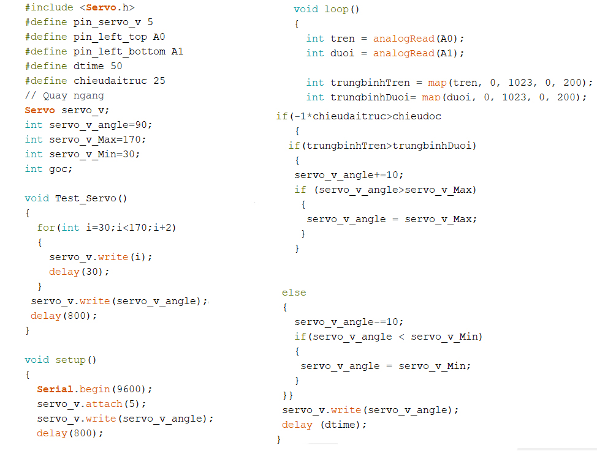

Figure ‑: Tracking solar code interface on software

*Figure 3. SEQ Figure_3. \* ARABIC 3. Save programming to the document*

### The Blynk platform

Blynk is a platform with smartphone applications that can easily interact with microcontrollers such as: Arduino, Esp8266, Esp32 or Raspberry over the Internet and not be tied to a specific board or shield. Instead, it supports the hardware this project chooses. suitable for project hardware such as Arduino (MEGA) linked to Internet via Wi-Fi, ESP8266 chip, Blynk will help this project connect and ready for IoT.

* Blynk Server – responsible for all communication between the smartphone and the hardware. You can use Blynk Cloud or run your project's private Blynk server locally. It is open source, can easily handle thousands of devices and can even be launched on Raspberry Pi.
* The Blynk library – for all popular hardware platforms – allows to communicate with the server and process all incoming and outgoing commands.
* Every time a user presses a button in the Blynk app, the message travels to the space of the Blynk cloud, and finds its way to the project's hardware.

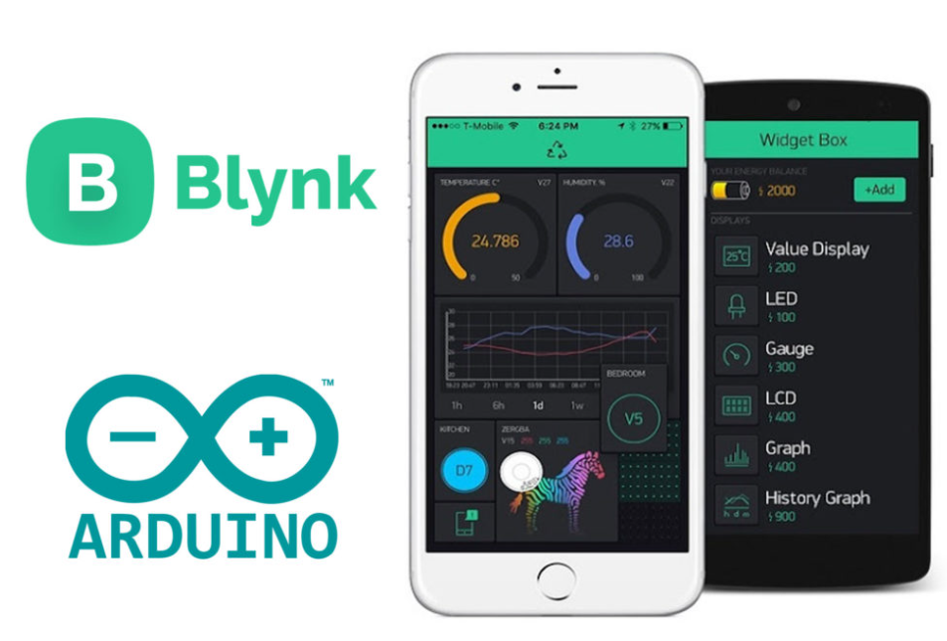

Figure ‑: Blynk interface

# RESULTS AND DISCUSSION

## Describe the operating procedure

The following diagram shows the components of the solar system in our project.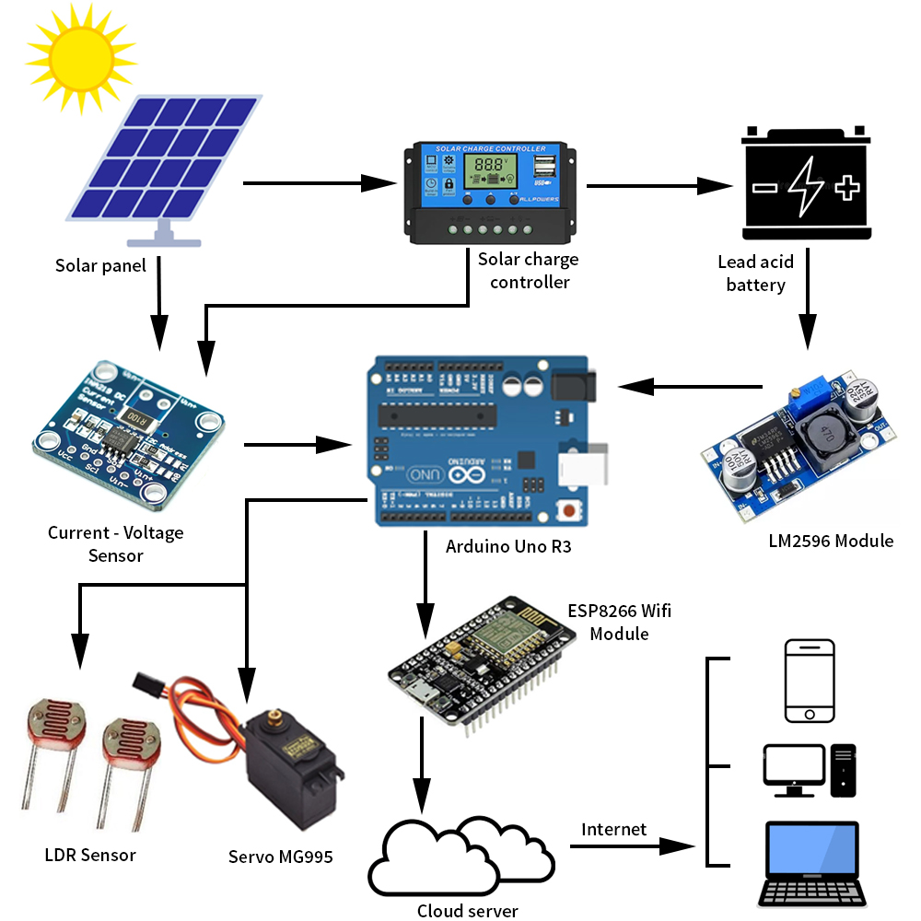

Figure ‑: Operation diagram

Solar panels power the entire system. A PWM system that manages the charge for the lead acid battery to store electricity is created by the battery's voltage. The battery powers the apparatus when there is no sunlight. The voltage will be lowered from 12VDC to 5VDC using a step-down module due to the voltage differential between the battery and the module. The ESP8266 module will record the parameters and communicate them over the Internet via the Blynk application, allowing anyone with an Internet-connected device to monitor them from anywhere. The project is most effectively employed to control the solar panels toward the sunniest side and monitor the energy capacity of the solar cells.  
  
The technology used by this module, as shown in the diagram, modulates infrared light, and the receiver section only detects infrared light when it has gathered the right signal. Consequently, reducing the amount of interferences from the immediate surrounding light

* In order to collect data automatically, it must first be connected to the Internet via the ESP8266, displayed on an LCD, and activated the 9 sensors of the system.
* Based on that, the microprocessor will compute, process, obtain the findings and then download to the computer all of the values that the system's nine sensors have returned. ESP8266 connected to master (Blynk). When the system is activated, every process is automatic.

The user will monitor all programmed values via the Blynk server, and the requirement for the system to function is to maintain an Internet connection between the user and the entire system. As a result, we use mobile phone so there is no need to reload the code. We outline the WiFi data kept on the ESP8266.

* SSID: Graduation
* Password: 123456789

## Solar tracking operation

I use 2 photoresistors and 2 10kOhm resistors to determine the direction of the sun. Install a baffle to separate 2 photoresistors, when 1 photoresist receives more light, the other photoresistor will be obscured by the baffle, this means the measured values of the 2 photoresistors will be different. Whichever one of the 2 photoresistors receives more light, the signal will be transmitted to the servo motor and rotate to an angle where both photoresistors receive equal light.

## Analysis

To reinforce the panels, I looked about and made use of things like iron V-bars. When used as a frame, a servo motor, iron is a hard, strong material. if the panel's force load is reduced, the rotation will be more precise. Another substance that can survive the elements of the outdoors is iron.

Overview in order to the tracking solar toward the light source where it will receive the maximum energy, the solar tracker uses a single servo motor with a 180 degree rotation angle.

I calculate the weight of the frame so that the servo can perform at its best. Because according to table (3.4) plate weight is 1.94kg. I choose servo MG996 to rotate the vertical axis, this motor has a pulling capacity of up to 3.5kg so it can completely rotate the solar panel.

After completing the goal that I set, I developed an IoT that can track the energy received by the panel, the energy taken from the solar cell that day. I get data for both cases:

* Case 1: The solar panel is placed in one direction.
* Case 2: The solar panel uses the navigator by sunlight.

### Testing without tracking solar

For the most objective test results, I put the surface of the panel facing up to a 90 degree angle. Measurement parameters will be manually taken 5 times in 1 hour by VOM meter, then the power received in 1 hour will be calculated.

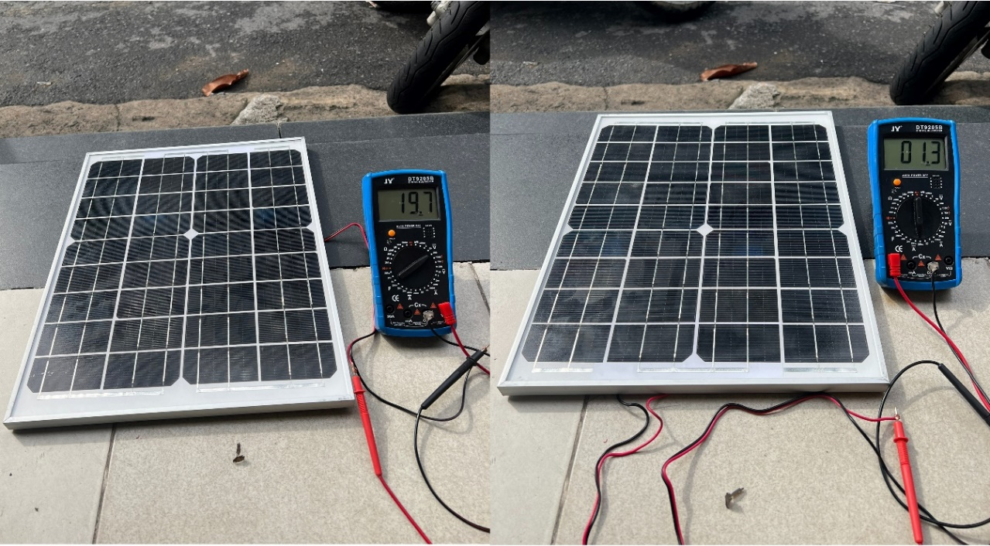

Figure ‑: Testing without non-tracking solar

Measurement results according to the times of the day when not using the tracking solar system are shown in the table below:

Table ‑: Measured parameters without the tracking solar system

|  |  |  |  |  |  |  |  |  |  |  |
| --- | --- | --- | --- | --- | --- | --- | --- | --- | --- | --- |
|  | 7h | 8h | 9h | 10h | 11h | 12h | 13h | 14h | 15h | 16h |
| Voltage(V) | 13,2 | 16,9 | 19.7 | 21 | 21,2 | 21,4 | 20,9 | 19,1 | 17,5 | 15,4 |
| Current(A) | 0,23 | 0,6 | 0,91 | 1,3 | 1,4 | 1,4 | 1,31 | 0,88 | 0,73 | 0,59 |
| Power(W) | 3,05 | 11,6 | 17,9 | 28,5 | 29,6 | 29,9 | 27,11 | 16,8 | 12,7 | 9,1 |
| Total (W) | 186,7 | | | | | | | | | |

### Testing with tracking solar

In this case, I put the tracking solar system in the East direction, where the sun rises. The parameters will be measured by the pressure current sensor are

Measurement results according to the times of the day when using the tracking solar system are shown in the table below:

Table ‑: Measured parameters with the tracking solar system

|  |  |  |  |  |  |  |  |  |  |  |
| --- | --- | --- | --- | --- | --- | --- | --- | --- | --- | --- |
|  | 7h | 8h | 9h | 10h | 11h | 12h | 13h | 14h | 15h | 16h |
| Voltage(V) | 17.21 | 19,23 | 19,7 | 21,2 | 21,4 | 21,4 | 21,4 | 20,32 | 19,62 | 17,23 |
| Current(A) | 0,88 | 1,1 | 1,31 | 1,36 | 1,4 | 1,4 | 1,4 | 1,36 | 1,27 | 0,89 |
| Power(W) | 15,14 | 21,15 | 15,8 | 28,83 | 29,96 | 29,96 | 29,96 | 27,63 | 24,91 | 15,33 |
| Total (W) | 248,7 | | | | | | | | | |

### Comparison

Based on the above measured parameters, the graphs below will show the difference in voltage, load current, and power without the solar tracking and with the solar tracking.

Figure ‑: Voltage difference between 2 cases

Figure ‑: Current difference between 2 cases

Figure 4. Power difference between 2 cases

Figure ‑: power obtained in 10 hours between 2 cases

**Comment:** Observing the above graphs, we can see that the tracking solar system will improve the energy collection efficiency, the capacity of the directional system is higher than that of the non-tracking solar system at different times point of the day and the total power received in 1 day is also higher between the guided and non-guided panels. In particular, the tracking solar system brings the greatest efficiency in the early morning and evening time frames. The experimental results are also consistent with the theoretical basis of solar cell efficiency. Therefore, it can be concluded that the directional panel increases the solar energy harvesting efficiency significantly compared to the non-tracking solar system.

# CONCLUSIONS

## Final Hardware

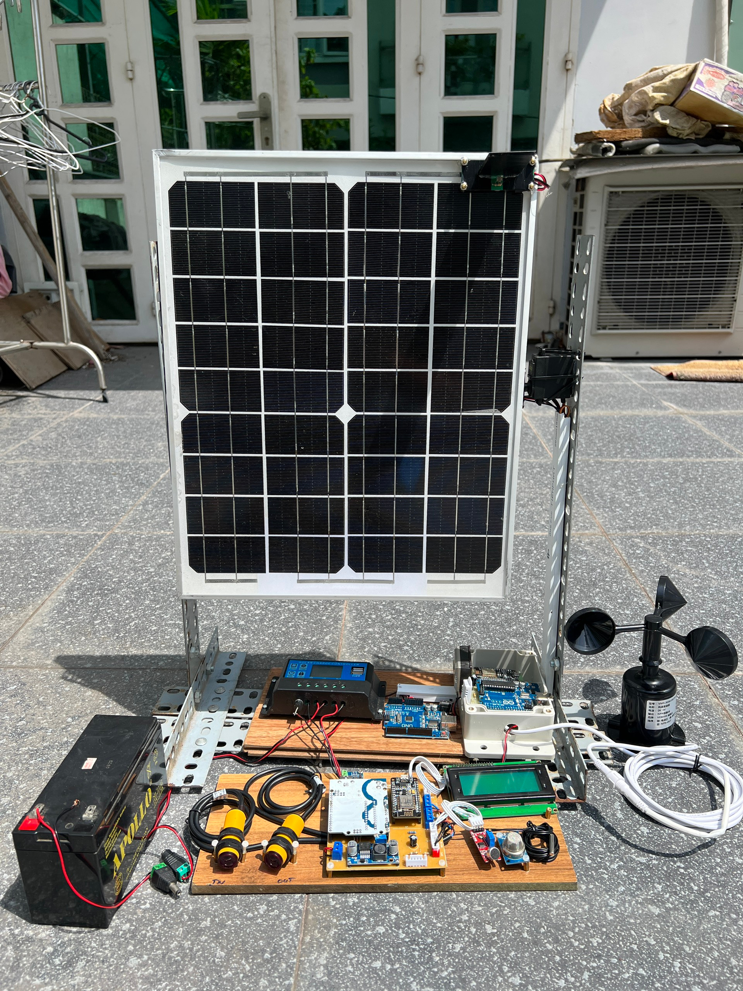

Figure ‑: The solar tracking of PV systems with hospital smart systems

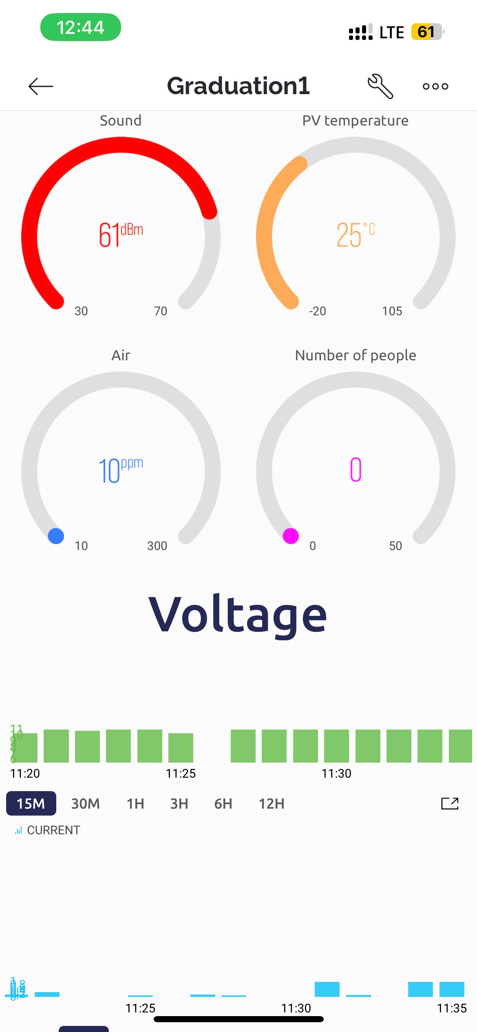

Figure ‑: Outcome on Blynk App

**Conclusion**: This thesis has provided a solution to increase the efficiency of solar collectors and can monitor the parameters of the solar panel system remotely via the Internet. Currently, navigational and monitorable solar systems on phones are currently being researched a lot around the world to optimize the energy obtained from the sun. The experimental and comparative results show that the proposed method achieves a relatively high degree of relative high, lower investment costs than existing approaches.

There are still many shortcomings, especially in maintaining and stabilizing the sensors, besides it needs to be perfected and improved on the programming part.

## Advantage of model

* Microcontrollers receive signals and process them quickly within the allowable range.
* The interface is intuitive and easy to monitor on phones and computers.
* Optimized energy transmission.
* Has a high practical application.

## Disadvantage of model

* Sometimes the sensor is noisy due to the impact of high light environment.
* Depends on internet speed.
* The model is experimental, the accuracy is not high.
* The model has also not been designed to be as compact as possible
* The budget does not allow using better sensors, so the accuracy is not high

## Future Works

It might be said that this project isn't actually utilizing the Internet of Things (IoT), but rather is only monitoring sensor data online. The solar navigation model has several flaws because it is merely a simulation of how the system works.

Although the products are of poor quality and durability, they are nonetheless sufficient for testing. The next projects will involve improving the product's quality, the device will be upgraded to be of higher quality and capable of being remotely controlled in addition to data collection and processing on behalf of people.

The device will be upgraded to be of higher quality and capable of being remotely controlled in addition to data collection and processing on behalf of people.

# REFERENCES

1. Instructions for installing and using Blynk, Retrieved on 16-06-2023, availabe https://nshopvn.com/blog/huong-dan-cai-dat-va-su-dung-blynk-new-2-0-tren-arduino-ide-voi-esp8266/
2. Pérez-Lombard, L., Ortiz, J., & Pout, C. (2008). A review on buildings energy consumption information. Energy and buildings, 40(3), 394-398.
3. Benjamin Spahic. (2020). Arduino Without Prior Knowledge: Create your own first project within 7 days, Become an Engineer Without Prior Knowledge (pp.53-82)
4. Rizazollah Firoozian, (2009). Servo Motors and Industrial Control Theory. Mechanical Engineering Series.

[5] Mohammad Azam,Tejmani Kumar,Munendra Singh, “Sun Tracking Solar Panel System”, International Journal of Computer and Electrical Engineering.

[6] Purnima Singh, Roop Pahuja, Meghavi Karwasra, Sunita Beniwal, Meenakshi Bansal, Anamika Dadhich (2016), “Dual Axis Solar Tracking System for Solar Panel”, Bulletin of Electrical Engineering and Informatics, pp. 403-411

[7] Electricity consumption, Retrieved on 12-06-2023, available <https://www.iea.org/reports/electricity-information-overview/electricity-consumption>

[8] Renewables Catching Nuclear Power In Global Energy Race, Retrieved on 12-06-2023, available <https://www.forbes.com/sites/rrapier/2019/07/07/wind-and-solar-power-nearly-matched-nuclear-power-in-2018/?sh=77b5d9da39ee>

[9] Tiềm năng điện mặt trời tại Việt Nam, Retrieved on 12-06-2023, available <https://baochinhphu.vn/tiem-nang-dien-mat-troi-tai-viet-nam-102277349.htm>

[10] Solar cell construction and working principle, Retrieved on 12-06-2023, available <https://electricalengineering123.com/solar-cell-construction-working-principle/>